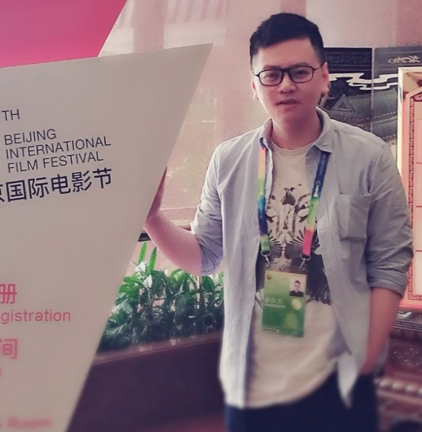

**CHEN JIANFENG**

**Press Release**

Interfax Business Wire Services (EN>ZH)

* Responsible for the translation of press releases around high-tech, life & entertainment, transportation, culture and others on a daily basis since 2012

Other established companies (EN>ZH / ZH>EN)

* Schneider Electric, GroupM, Wechai Lovol, Zoomlion, Danfoss, Chery, Geely and more

**Magazine/White Paper**

Bosch in China (EN>ZH / ZH>EN)

* Participation in the translation of the Bosch Zünder, international in-house magazine of the Bosch Group, from English to Chinese on a quarterly basis, and of in-house magazine of Bosch in China from Chinese to English

Schneider Electric (EN>ZH / ZH>EN)

* Participation in the translation of white papers and other promotional collaterals of Schneider Electric since 2009

**Lifestyle**

NIKE (EN>CN)

* Responsible for the trancreation of NIKE products mainly including shoes from 2011 to 2014
* Responsible for the translation of Valentino products from 2015 to 2017
* Responsible for the translation of Dabo services from 2021 to present

**Sports (ZH>EN / ZH>CN)**

* Beijing 2022 (2018 - early 2019)
* The 19th Asian Games Hangzhou 2022 (2019 to present)
* Sina Sports News (late 2021)

**Major International Events (In Person/Virtually, ZH>EN)**

* Beijing International Film Festival (2016 to present)
* Silk Road International Film Festival - Fuzhou (late 2021)
* Eco Forum Global Guiyang (2015 - 2019)
* Big Data Expo, China International Import Expo, …

**Book (EN>ZH)**

* *The Rise of a Lifetime* by Robert Iger

**Miscellaneous (ZH>EN / EN>ZH)** (incl. localization, government projects, and annual report)

Interfax China, Schneider Electric, UNESCO, Bosch, Siemens, GroupM, Dabo, Baidu, NIKE, MOOC, etc.

Freelance Translator (15+ yrs)

Native Language: Chinese

Language Pairs: English and Simplified Chinese

**CAT TOOL AND VERSION**

**EDUCATION BACKGROUND**

**AREAS OF SPECIALIZATION**

China Accreditation Test for Translators and Interpreters (CATTI)-Level 2

SDL Trados (2019)

**COMPANIES SERVED**

High-Tech, Art & Culture, Life & Entertainment, Sports, Travel, Business and E-Commerce, Multimedia, Localization

**CREDENTIAL**

**Nanjing Normal University**

School of Foreign Languages and Cultures

**PROJECT EXPERIENCE**

michael_chen_0817@163.com

Shanghai, China (GMT+8)

**CONTACTS**