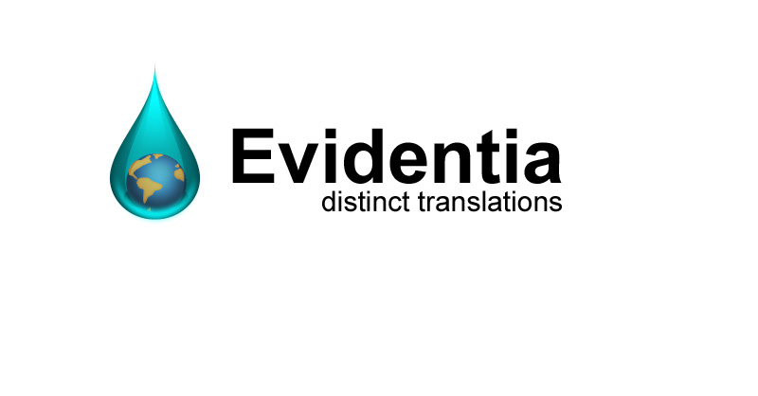

Claire Loveridge BA(HONS)

E-mail: Claire@evidentia.co.uk
Telephone: +44 (0) 78 79 47 29 29

Meticulous French to English Translator with 15 years' experience in translation. Excellent language skills and a high standard of English. Adept at retaining the original meaning, style and unique characteristics of original words and documents when completing professional translations.

KEY SKILLS
- Many years’ experience in the corporate world before becoming a freelance translator
- Professional and friendly with accomplished communication skills
- Build long lasting relationships with clients through exceptional customer service
- Cultural understanding and knowledge of business operations
- Microsoft Office/Trados Studio/XTM
- Professional indemnity insurance

LANGUAGE SERVICES

With a passion for translations that convey their message using appropriate terminology, I produce flowing, accurate and reliable French to English translations.

I am customer focused, calm and professional in difficult situations and always on hand to listen to concerns and answer questions regarding delivered translations.

All deadlines and quality standards as set by the client and the requirements for each task are adhered to at all times.

Translation materials include: websites, contracts, press releases, blog posts, news articles, annual reports, profits and loss/balance sheets, business and marketing communications, software manuals, tenders and applications.

Translation subjects include: tourism, hotels, aerospace, technology, development cooperation, oenology, finance, education and e-learning, design, fashion, cosmetics, marketing, the environment.

I have translated for various organisations ranging from small companies to large well-known brands as well as government departments and ministries.

Some of the organisations I have produced translations for include: L’Oréal, STEF Logistics, UNESCO, Gucci, the Walloon Government, City of Brussels, Achouffe Brewery, SNCB, Accor Hotels, Les Ballets de Monte Carlo.

SPECIALIST EXPERIENCE

My specialist experience stems predominantly from the many years I spent in the corporate world prior to becoming a freelance translator:

Business:
Several of my roles involved managing day-to-day business operations, including human resources, marketing and finance within SMEs. As a Business Manager I oversaw hiring and recruitment, performed monthly payroll and coordinated record keeping. Business Studies was also a major component of my degree. I therefore have an invaluable understanding of all areas of business.

Websites:
Working for a web development company gave me an understanding of the importance of a good website. I recognise that a website must work for the client in each particular language; this not only means good content, but also keyword analysis and search engine optimisation processes.

Marketing:
As a Marketing Assistant for a software development company, I was involved in all aspects of marketing including advertising campaigns, prospecting, trade shows and events. Consequently, I am conversant in the terminology for this industry and aware of the importance of expressing the message of a campaign, rather than simply translating words.

QUALIFICATIONS

- BA (Hons) degree in French and Russian with Business Studies from Swansea University, Swansea, UK

CAREER SUMMARY

April 2005-date Translator

2004-2006 Web on High Limited, Business Manager
2003-2004 ARC Training, Business Manager
2000-2002 IBS (Public Services) Ltd, Marketing Assistant
1997-1998 Experian Limited, Customer Service Officer
1996-1997 United Parcel Services, Customer Service Agent

INTERESTS

Running and health, gardening, theatre, ballet and the arts, reading, travelling, passionate about plants, wildlife and the environment.

I am also a volunteer for Guide Dogs, providing boarding facilities for puppies in training.

