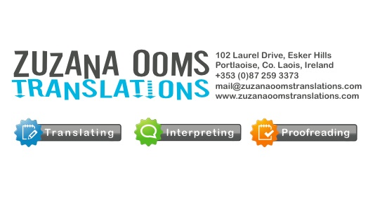

Freelance Translator, Interpreter, Proofreader, Linguist, Localization Specialist
Main language combinations Japanese-English, Japanese-German, English-Slovak, English-Czech, Russian-English, German-Russian & other

Highly professional, experienced linguist, translator, interpreter and localization specialist with hands-on inside experience across many sectors. Passionate, accurate and customer oriented person with strong focus on individual details on project-by-project basis. I can offer an experience in connection to languages, whether translating, interpreting, using for enabling companies and clients to communicate for over 13 years.
Sex: female
Date and Place of birth: 07.05.1976, Bratislava, ex. Czechoslovakia
Current Address: 102 Laurel Drive, Esker Hills, Portlaoise, co. Laois, Ireland
Nationality: Slovak
Mother tongue: Slovak / Czech
Foreign languages: fluent: English, German, Italian, Japanese, Russian, read and speak: French, basic: Korean & Latin
Mobile: +353-87259 3373
Tel: +353-57-8688964
Fax: N/A
Main Email: info@zuzanaoomstranslations.com
Secondary Email: ooms.zuzana.translations@gmail.com

Web page: www.zuzanaoomstranslations.com
MSN: zooms
Skype: ooms.zuzana.translations
Yahoo messager: N/A
ICQ: N/A
Education:
High School Srobarova, Kosice, Slovak Republic – language studies : English, German 1990-1994
Vienna University – Japanese and Korean studies, 1994-2000
Kyoto Royal University – exchange program QUINEP focus on Japanese language, culture, economics and technology 1997-1998
Kyoto Royal University – Research for diploma thesis “Beginnings of woman in Kendo, as a classical male sport".
Working Experience:
Kuoni
Dell Computers
Apple Computers Ltd.
Business Objects
Google
ORF1
Wealth Options
Austria Card
Wordtrans.org
My Rhyme
Cosmic Global
Global Change
Rose Translations

Esoon

Translations Services USA

Nordexpansion

QuickSec Translations

Prematrans

Transperfect

Daily average output: 8000 words
Software used: SDL Trados Studio 2009 Plus, Passolo, Idiom Wordserver Desktop Workbench, Adobe CS4 Suite, MS Office (Vista)
Areas of expertise: patents, biomedicine, biochemistry, medicine, technical and medical translations, IT, Software, tourism, marketing, literature

