Résumé

Contact Details_________________________________________________________________

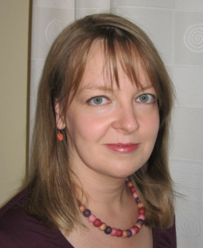
Ms Nicole RUMP
Horst 5
58762 Altena
Germany

Tel. + 49 (0)2352 333379
Fax +49 (0)3222 1555894
Mobile: + 49 (0)175 – 2062583
Mail: nicole.rump@t-online.de
Website: http://www.rump-translations.de.vu

Personal Information____________________________________________________________

Date of birth: 20th March 1975

Job: Employee in sales / export (supplier to automotive industry)

Languages_____________________________________________________________________

Language pairs: German to English
English to German

Mother tongue German

Fluent English, French

Read/written Spanish, Italian

Career profile__________________________________________________________________

April 2004 to present: Freelance translator (German to English, English to German)

February 2004: Examination as state-approved Interpreter and Translator (English);
Grade: distinction (Chamber of Commerce and Industry Dortmund)

December 2002: Examination as state-approved Translator (English); Grade: distinction
(Chamber of Commerce and Industry Dortmund)

June 1998: Examination as Foreign Language Correspondent (English);
Grade: distinction (Chamber of Commerce and Industry Dortmund)

Major fields____________________________________________________________________

Automotive industry, cold forging, wire industry, metal processing, automation technology,
technical translations in general, economics, commerce and finance, commercial
correspondence, correspondence in general, private and commercial websites, travel, leisure and
tourism, advertising brochures/leaflets, newspaper advertisements, menu cards, press folders

Other services offered___________________________________________________________

Proofreading
Transcription (text – text / audio – text)

