Cecilia Mariela Anrriquez
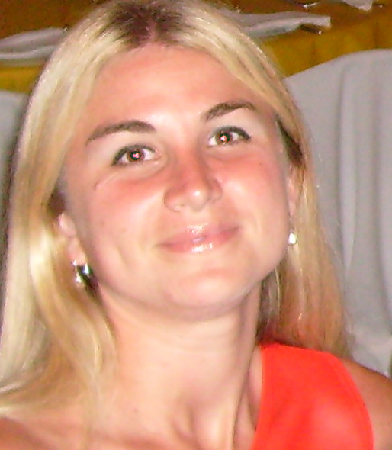
English to Spanish Translator and Editor

PERSONAL DETAILS AND BRIEF DESCRIPTION
Cecilia Mariela Anrriquez – Belgrano 379, Empalme Villa Constitución (2918) Santa Fe, Argentina
Phone numbers: 54 – 03400 – 493735 / Mobile: 54 – 03400 – 15663584
E-mail: ceciliaanrriquez@gmail.com
Skype ID: cecilia.anrriquez123
DOB: April 7th, 1978
Nationality: Argentine
Mother tongue: Spanish

I am English to Spanish translator and editor. I have worked as a freelance translator since the year 2000 when I got my degree in Literary, Scientific and Technical translation. Since then I have provided high quality translations in different areas, mainly in the legal field and in the medical field. I have recently specialized in the revision and correction of translations, being legal translations the main focus. I currently own and use SDL Trados Studio 2015. Registered at Proz.com: November 2005. Currently Certified PRO in English to Spanish.

WORK EXPERIENCE:
Translations and Editions for: ACINDAR (aeronautic – metallurgy)
CLÍNICA EMPALME (medicine, cardiology reports, informed consents, medical trials)
INDIVIDUALS: (high school certificates – birth certificates – manuals for electrical appliances – literary texts – legal documents - contracts)
INDUMONTAJES SRL (company description and staff document)
ACCURATE LANGUAGE SERVICES (hospital forms, admission agreements, birth certificates, legal documents, educational material, primary school exams, school brochures, school certificates, pamphlets and ads, divorce decree, criminal reports, transcriptions of detective interviews)
Oxfam Collaborator (translations and editions)
SERVICOM GROUP: legal documents - foreign trade - customs documents –
BRAM POLDERVAART: Translation and revision of Astrology books for the European market.
MONICA REY: translations and editions for the American market.
TERMWIKI: collaborator in the translation and edition of terms.
REASEARCH TRANSLATIONS: translations projects under the supervision of Igor Jovic. www.retrans.eu Germany.

EDUCATION:
2015 – 2016:
Theoretical and practical course: “Edition and correction of legal texts and translations” (Fundación Litterae)
2012: Course on “editing and proofreading” (Traductor Corrector) – Fundación Litterae. – Rosario – Argentina
2002: Post-graduate course on Translation (Bachelor Degree in English Translation) Facultad de Humanidades. Entre Ríos 758, Rosario.
2000 – 2001:
Postgraduate course: Subjects: English Language IV – Technical and Scientific Translation II – Instituto Superior de Profesorado N°3 “Eduardo Lafferriere”. Villa Constitución.
1996 – 2000:
Traductorado Literario y Técnico-Científico en Inglés. Instituto Superior de Profesorado N°3 “Eduardo Lafferriere”. Villa Constitución. (Final Mark: 4.18: four. 18)
TRANSLATION FIELDS:
Legal translation - Health and medicine – Samples on request.
COMPUTER SKILLS:
SDL Trados Studio 2015 – I’m a fast learner and I can adjust to specific software requirements. Excellent knowledge of windows and Microsoft Office.
INTERESTS:
Running: I am an enthusiastic runner and I usually take part in marathons and running events in the area I live.
School Association collaborator: I am an active collaborator in a pre-primary public school. The association is made up of a group of parents and we regularly organize different events in order to raise funds for the improvement of the school building and for the acquisition of new equipment and different amenities.

OTHER INFORMATION:
*AATI member since July 2015. (Asosciación Argentina de Traductores e Intérpretes: Argentinian Association of Translators and Interpreters)
*Proz.com Certified PRO translator.
*Member of the Professional Association of Translators (2nd. District) of Santa Fe Province, Argentina. License date and number: August 2nd, 2000 – 327-02.
*You may also check my translation profile at www.proz.com/profile/34665 and https://ar.linkedin.com/in/cecilia-anrriquez-2a0a163a
*Proficiency Level in Business English (International Exam: BEC 3, Cambridge University) - 2001
*Certificate of Proficiency in English - Pine Manor College (Boston, United States)- 1998
*FCE (International Exam, Cambridge University) – 1994
REFERENCES:
Available upon request.

