**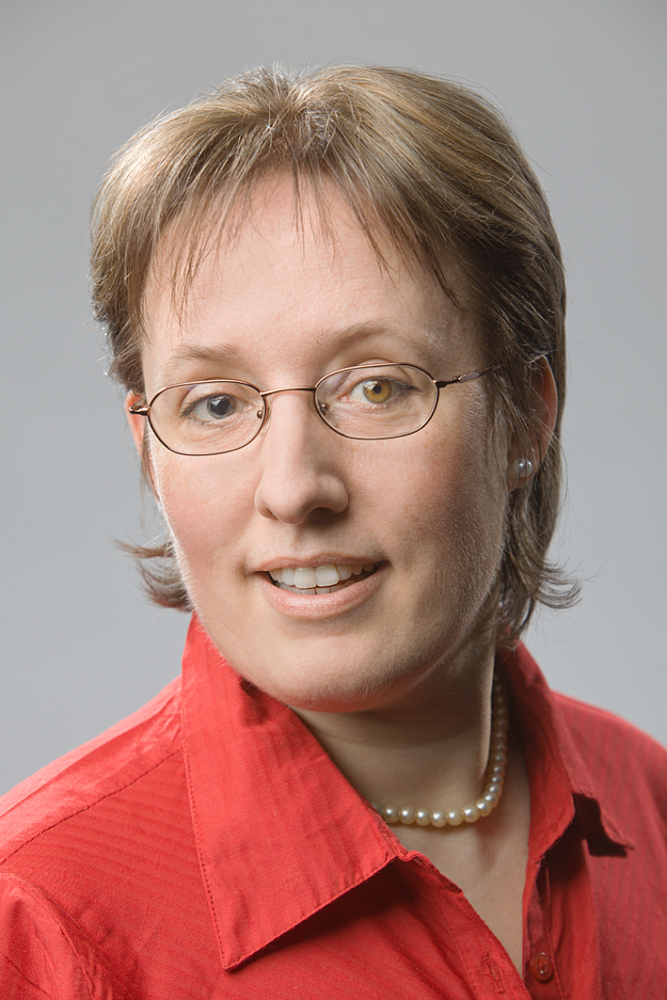******

* **Operating system Windows 10 Pro**
* **Word for Windows**
* **Adobe Acrobat Reader Pro DC**
* **Power Point 2007**
* **Excel 2007**
* **MemoQ 8.1**

<https://twitter.com/GertrudHurck>

linkedin.com/GertrudHurck

**Address:**Friedrich-Ebert-Str. 99

48153 Münster

**Telefon:** 0170 - 2888870

**E-Mail:** [uebersetzungen@hurck.de](mailto:uebersetzungen@hurck.de)  
**Web**: www.hurck.eu

* SWORN BEFORE THE HIGHER REGIONAL COURT OF HAMM
* UNIVERSITY CERTIFIKATE “CERTIFICATE OF SPECIALISED KNOWLEDGE OF LEGAL LANGUAGE“
* ADV. TRAINING “INTRODUCTION TO THE FRENCH COURT SYSTEM“

**GERTRUD HURCK**

Short profile

**PROFESSIONAL EXPERTISE**

**PROFESSIONAL TRANSLATOR FOR   
ENGLISH AND FRENCH**

**CAREER**

**ADDITIONAL QUALIFIKATIONS**

**IT**

**LEGAL TEXTS**

I cooperate with law firms and receive juridical translation assignments from courts and private clients. The translation of legal texts requires factual knowledge and terminological security regarding the different fields of law. I am proficient in the translation of a wide variety ot specialized texts, such as: briefs, complaints, jugdments, notarial recordings, documents pertaining to divorce and maintneance law, adoption and custody matters, foreign acts and regulations such as transfer pricing, documents relating to real estate acquisitions, insurance documents etc.

**BUSINESS ADMINISTRATION AND FINANCE**

Due to the progressing globalization the demand for precise high-quality translations has substantially increased. In order to be able to compete and succeed in international markets multi-language knowledge and specialized expertise are indispensible. I translate documents relating to the formation of and incorporation of enterprises such as shareholders‘ agreements, statutes and articles of association, investment agreements and commercial register excerpts, moreover business plans, audit reports and financial statements, GTC and supplier contracts, purchase agreements, licence and sales contracts, NDA, facility and suretyship contracts, full-time and temporary employment contracts, job specifications, tender documents as well as documents and agreements relating to stock trading, insurance documents and correspondence.

**MEDICINE**

In the course of my translation activity I also gained some expertise in medical translations - apart from medical certificates I also translate diagnoses and release reports, PR of hospitals and medical institutions, medical papers and articles, medical testimonials, diploma and licenses.

After I completed my translator studies at the University of the Saarland (minor subjects Economics and Business Administration) I worked in full-time employment as a translator in a conveyor-producing company for two years and set up my freelancer business in 1995. On the one hand, I work for direct customers such as attorneys and companies, on the other hand with agencies. I am in contact with a German-speaking lawyer who provides me with background information.